COMSOL Multiphysics Pvt. Ltd.  Esquire Center, C - Block, 3rd Floor,  No. 9, M.G. Road, Bangalore 560001, India  Tel:+91-80-2559-7799  Web: www.comsol.co.in  E-mail: info@comsol.co.in | Media Contact:  Ashwin S. Mecheri,  ashwin@comsol.com  Image Gallery:  www.comsol.co.in/press/gallery

First Look at the Latest COMSOL Multiphysics® Software Unveiled at the COMSOL Conference 2017

Attendees at the COMSOL Conference 2017 Rotterdam enjoyed a sneak preview of new software features, technical panel discussions on medical and acoustics simulation, minicourses, and presentations of papers and posters on cutting edge multiphysics modeling.

BANGALORE, INDIA (October 20, 2017) — COMSOL, the leading provider of software solutions for multiphysics modeling and simulation app deployment, provided attendees with a sneak preview of the latest updates of the COMSOL Multiphysics® and COMSOL Server™ products at the annual COMSOL Conference in Rotterdam. Attendees learned about current and future developments of the software from Svante Littmarck, President and CEO, COMSOL, Inc. during his keynote address. “Our customers are at the forefront of innovation behind the products that will shape our future,” says Littmarck. “We work tirelessly to support their efforts by increasing the modeling power of the COMSOL® software and by making collaboration among simulation experts and their colleagues the core of everything we do. This annual event is our opportunity to connect and exchange knowledge within the COMSOL community on multiphysics modeling.”

Looking Ahead at the Upcoming Release
The most noteworthy updates in COMSOL Multiphysics 5.3a scheduled to be released in the fourth quarter of 2017, are:
- Acoustics and acoustic-structure interactions based on a hybrid boundary element-finite element (BEM-FEM) method
- Impulse response for ray acoustics
- Magnetostatics based a hybrid boundary element-finite element (BEM-FEM) method
- Shape memory alloy (SMA) materials for structural analysis
- Revolutionary new method for capacitively-coupled plasma (CCP) simulations
- Support for 3DConnexion® SpaceMouse® devices
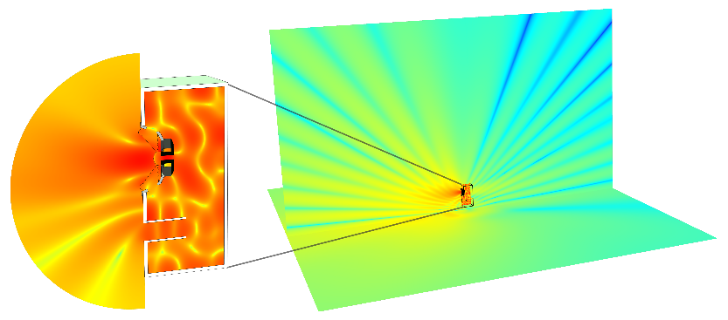
- Turbulent-flow enabled inlets for CFD simulations
- 150 new materials and 1300 new material properties in the Material Library product
- More than 60 substrate material properties for RF and microwave analysis

“We are excited to now offer acoustics analysis based also on the boundary element method. It’s a great addition that many of our users have been waiting for”, says Mads Jensen, Technical Product Manager, Acoustics, at COMSOL. “By combining boundary element, finite element, and ray acoustics analysis in a multiphysics environment, our users get unprecedented modeling power. Users can now efficiently analyze the full range of acoustic frequencies from the lowest bass notes to ultrasound. Not to mention all the possible multiphysics couplings.”
The sound pressure level (SPL) surrounding a vented speaker, computed with the boundary element method combined with finite-element-method-based modeling using 125k finite elements, 20k boundary elements, and 250k degrees of freedom. Using just finite elements would have required ½ billion finite elements for the same accuracy.

Those in attendance had the opportunity to test the beta version of the software to try out this new feature, along with many updates to be announced later this year.

COMSOL Conference 2017 at a Glance
The COMSOL Conference features a robust technical program with seven events held around the world. The second stop in Rotterdam attracted about 300 attendees. Over one hundred user presentations were given. Panel discussions on medical and acoustics simulation were highly anticipated new additions to the program. The exhibit featured technical computing software and services, hardware providers, and HPC specialists among others. A wide span of breakout sessions included minicourses and technical workshops on topics ranging from heat transfer, and structural mechanics, to meshing, solvers, optimization, postprocessing, cluster computing, and more.

For more information, visit www.comsol.co.in/conference/rotterdam.

About COMSOL
COMSOL is a global provider of simulation software for product design and research to technical enterprises, research labs, and universities. Its COMSOL Multiphysics® product is an integrated software environment for creating physics-based models and simulation apps. A particular strength is its ability to account for coupled or multiphysics phenomena. Add-on products expand the simulation platform for electrical, mechanical, fluid flow, and chemical applications. Interfacing tools enable the integration of COMSOL Multiphysics® simulations with all major technical computing and CAD tools on the CAE market. Simulation experts rely on the COMSOL Server™ product to deploy apps to their design teams, manufacturing departments, test laboratories, and customers throughout the world. Founded in 1986, COMSOL employs more than 480 people in 21 offices worldwide and extends its reach with a network of distributors. www.comsol.co.in/contact
~
COMSOL, COMSOL Multiphysics, Capture the Concept, and COMSOL Desktop are registered trademarks of COMSOL AB. COMSOL Server, and LiveLink are trademarks of COMSOL AB. Other product or brand names are trademarks or registered trademarks of their respective holders. For a list of such trademark owners, see www.comsol.com/tm.

