COMSOL, Inc.
1 New England Executive Park, Ste 350
Burlington, MA. 01803 USA
Phone: +1 781-273-3322
Fax: +1 781-273-6603
Web: www.comsol.com
E-mail: info@comsol.com
Editor contact:
Bernt Nilsson, Senior VP of Marketing, bernt@comsol.com

Note to editors: Hi-res files for the following images are available for download at http://www.comsol.com/press/imagegallery.php

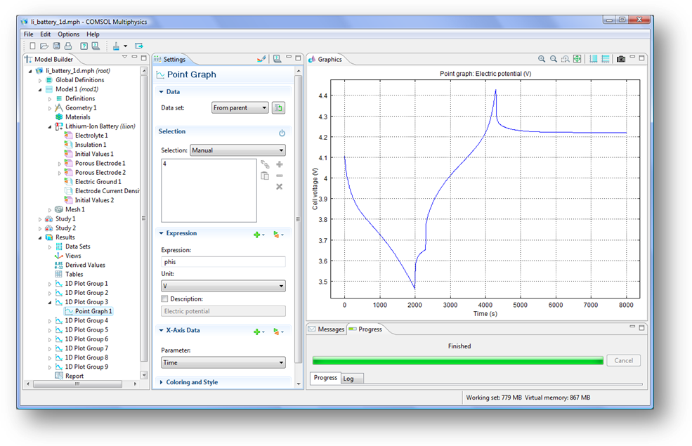
The new Batteries & Fuel Cells Module for COMSOL Multiphysics comes with predefined interfaces that speed up design studies. Here, the lithium-ion battery physics interface was used to simulate a battery’s discharge-recharge cycle.

New Batteries & Fuel Cells Module for COMSOL Multiphysics Released

Easy to use tool simulates all electrochemical devices; built-in interfaces make analysis set up fast, maximize productivity

BURLINGTON, MA (September 21, 2010) — COMSOL Inc., the developer of the COMSOL Multiphysics simulation software, announces the release of the Batteries & Fuel Cells Module for COMSOL Multiphysics modeling and simulation environment. This new, optional expansion module provides a full set of easy-to-use tools for the set-up, simulation, and study of all major electrochemical batteries and fuel cells, including lithium-ion batteries, nickel metal-hydride batteries, solid oxide fuel cells, and proton exchange membrane fuel cells. With the Batteries & Fuel Cells Module engineers, scientists, and researchers can investigate in deep detail the influence of different materials, geometric configurations, and operating conditions on the performance of batteries and fuel cells quickly and accurately.
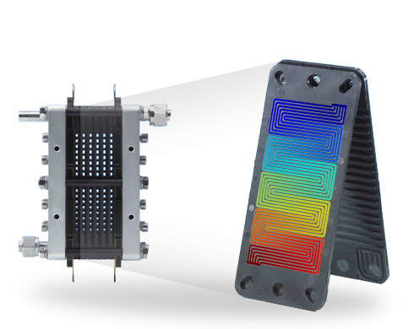
Hydrogen concentration in a proton exchange fuel cell as simulated with COMSOL’s
new Batteries & Fuel Cell. Model courtesy: Christian Siegel, Center for Fuel Cell Technology
(ZBT GmbH) in Duisburg, Germany.

The Batteries & Fuel Cell Module for COMSOL Multiphysics enables integrators and developers of batteries, fuel cell components, and fuel cell stacks in such industries as transportation, green energy, and consumer electronics to obtain accurate and reliable simulation results quickly. The COMSOL Multiphysics environment is engineered to facilitate the simulation of multiple, coupled physical phenomena, making it an ideal platform for simulating the behavior of batteries and fuel cells where multiple, coupled physical mechanism are ever-present. The Batteries & Fuel Cells Module extends COMSOL Multiphysics with predefined couplings of electrochemical reactions, flow, heat transfer, and electric fields. Users leverage this powerful combination to quickly set up and model the behavior of their battery and fuel cell designs using real-world materials and operating conditions.

“The new Batteries & Fuel Cells Module is capable of simulating just about any electrochemical process. It provides ready-made interfaces that deliver unprecedented ease of use and speed to model creation and simulation,” says Henrik Ekstrom, product technology manager with COMSOL.

“The design of single fuel cells and fuel cell stacks requires an in-depth understanding of the physics inside, including free and porous media flow, species distribution such as hydrogen or oxygen concentration over the electrode or sophisticated tempering concepts,” explains Christian Siegel with ZBT Duisburg GmbH, one of the largest institutes in Germany researching fuel cell technology.

At ZBT approximately 100 employees work in application-oriented projects for the establishment of fuel cell technology in areas such as auxiliary power devices and decentralized power generation. “By using COMSOL Multiphysics we have been able to study these mechanisms in detail and are able to deliver highly efficient membrane fuel cell solutions for systems and applications. The Batteries & Fuel Cells Module speeds up the model building process significantly and lets us focus on designing innovative new solutions for the market faster than ever before.”

Physics interfaces speed up electrochemical process simulation

Physics interfaces built into the Batteries & Fuel Cells Module enable engineers and scientists to set up their analyses quickly. Each interface includes descriptions of the electrochemical reactions and the transport properties that influence the performance of batteries and fuel cells. The described transport phenomena are chemical species transport, charge transport, heat transfer, and fluid flow. Electrode reactions, which are fully coupled to the transport phenomena, provide full descriptions of the electrode kinetics including activation and concentration overpotential.

. 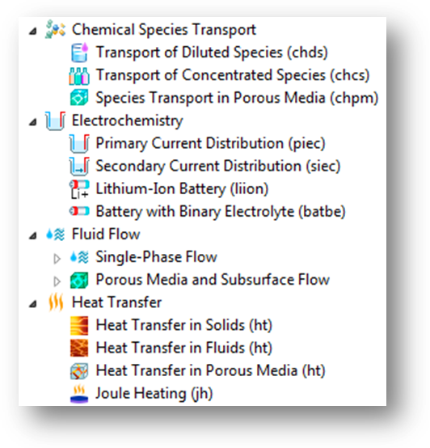
The new COMSOL Batteries & Fuel Cells Module has ready-made physics interfaces that makes model set-up quick and maximize productivity by automating solver choice, settings and study type.

Batteries & Fuel Cell Module Highlights

- Enables fast prototyping of all major types of battery and fuel cell applications
- Simulates the fundamental processes in the electrodes and electrolytes of batteries and fuel cells
- Comes with built-in analysis types for simulating operating conditions, electrode configurations, structures and dimensions, materials, and chemistry
- Includes tailored physics interfaces for
- Electrochemistry
- Chemical species transport in free and porous media
- Single-phase, porous media, and combined free and porous media flow
- Heat transfer in fluids, solids, and in porous media
- A complementary model library provides tutorials for the following electrochemical cells: molten carbonate fuel cell, direct methanol fuel cell, proton exchange membrane fuel cell, solid oxide fuel cell, lithium ion battery, nickel-metal hydride battery

About COMSOL Multiphysics

COMSOL Multiphysics is a software environment for the modeling and simulation of any physics-based system. A particular strength is its ability to account for multiphysics phenomena. Optional modules add discipline-specific tools for acoustics, batteries & fuel cells, chemical engineering, earth science, electromagnetics, fluid dynamics, heat transfer, MEMS, plasma, and structural analysis.

This is COMSOL

COMSOL was founded in 1986. The company’s U.S. offices are located in Burlington, MA, Los Angeles, CA, and Palo Alto, CA. International operations has grown to include offices in the Benelux countries, Denmark, Finland, France, Germany, India, Italy, Norway, Sweden, Switzerland, the United Kingdom. Additional information about the company is available at www.comsol.com. Additional information about the company is available at www.comsol.com.

###
COMSOL and COMSOL Multiphysics are registered trademarks of COMSOL AB. Capture the
Concept, COMSOL Desktop, and LiveLink are trademarks of COMSOL AB.
Other product or brand names are trademarks or registered trademarks of their respective holders.

