COMSOL, Inc.
1 New England Executive Park, Ste 350
Burlington, MA. 01803 USA
Phone: +1 781-273-3322
Fax: +1 781-273-6603
Web: www.comsol.com
E-mail: info@comsol.com
Editor contact:
Bernt Nilsson, Senior VP of Marketing, bernt@comsol.com

COMSOL First to Offer Free Cluster Support for Multiphysics Simulations with Windows HPC Server

Users with floating network licenses can now run high-level simulations on any number of cluster nodes without additional fees.

PORTLAND, OR (November 16, 2009) — Today at the SC09, the premier international conference on High Performance Computing (HPC), COMSOL Inc., the leader in multiphysics simulation software, announced that with the upcoming release of COMSOL Multiphysics version 4.0 for Windows® HPC Server 2008 (HPCS) current users of a COMSOL Multiphysics® floating network license will have free and unlimited access to cluster compute power. The new COMSOL support for cluster computing means that any simulation job can now be deployed to any number of clustered computers at no additional cost to the user. Free support for cluster computing distinguishes COMSOL Multiphysics from other developers of simulation software who price their applications proportional to the number of computers and processors available to the user.

“COMSOL is the first developer of multiphysics software to take this step toward removing the financial barrier to large-scale simulation on cluster computing systems,” comments Bernt Nilsson, Sr. VP of Marketing with COMSOL, Inc. “Since multiphysics simulations can be computationally demanding, we have chosen to ensure our customers success by giving away the ability to run COMSOL Multiphysics simulations on any number of nodes free of charge.”

Out of the Box Speedup

COMSOL Multiphysics for Windows HPCS targets mainstream computing. Version 4.0 ports a flexible and intuitive simulation environment to parallel platforms that provides users a scalable and affordable cluster solution for virtual prototyping. All controls needed for configuring a cluster job with Windows HPC Server 2008 are readily available with the click of a button in the COMSOL graphical user interface. No command-line operations are needed.

Parallel computing is a key component to minimizing the time to solution for complex multiphysics problems. For maximum performance, the COMSOL cluster implementation can use shared memory multi-core processors on each computer or node in combination with the cluster distributed memory system. This brings a major performance boost by making the most out of the computational power available to users.

All current users of a COMSOL Multiphysics floating network license are eligible to run their simulations on a cluster system with an unlimited number of nodes without an additional charge. New users who purchase a floating network license will also be able run their simulations on a cluster system with unlimited number of nodes free of charge. COMSOL Multiphysics platforms support clusters on Windows Compute Cluster Server 2003, Windows HPC Server 2008, and Linux.

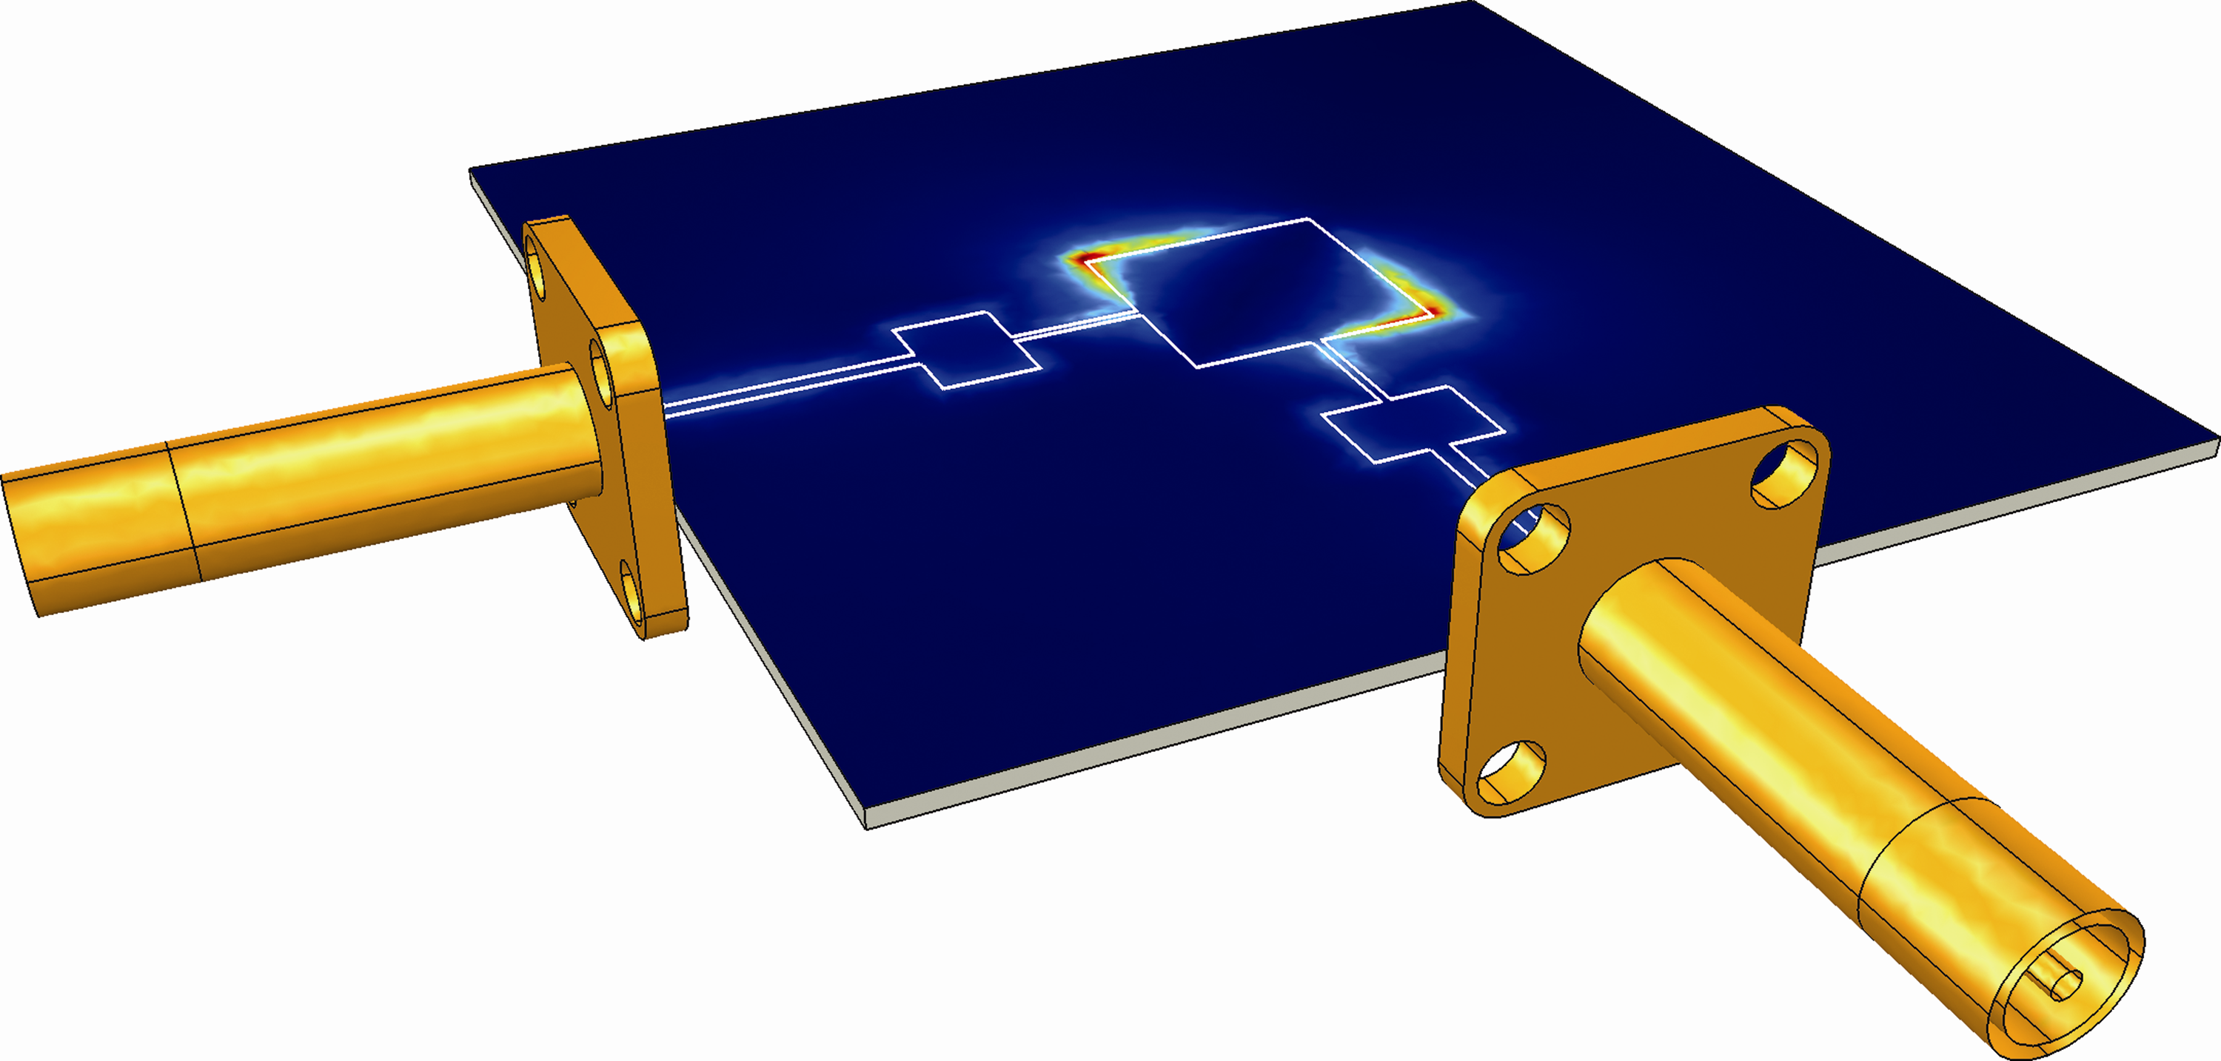  Benchmark data from an electromagnetic simulation of a patch antenna using COMSOL Multiphysics on a cluster. | 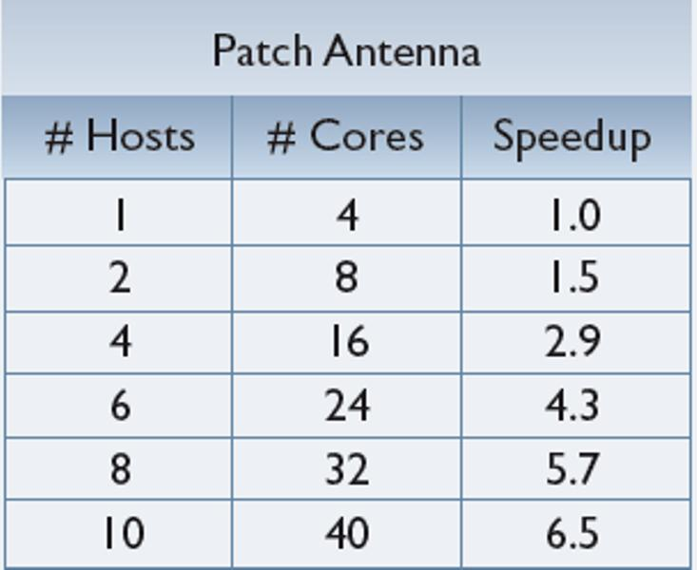

About COMSOL Multiphysics
COMSOL Multiphysics is a software environment for the modeling and simulation of any physics-based system. A particular strength is its ability to account for multiphysics phenomena. Optional modules add discipline-specific tools for acoustics, chemical engineering, earth science, electromagnetics, heat transfer, MEMS, and structural analysis. Another key product is COMSOL Reaction Engineering Lab®, which allows users to model reacting systems. COMSOL products are available for the Windows, Linux, and the Macintosh operating systems. Full details about COMSOL Multiphysics and related products are available at www.comsol.com.

This is COMSOL
COMSOL was founded in 1986 in Stockholm, Sweden, and has grown to include offices in the Benelux countries, Denmark, Finland, France, Germany, India, Italy, Norway, Switzerland, the United Kingdom, and in the US with offices in Burlington, MA, Los Angeles, CA, and Palo Alto, CA. Additional information about the company is available at www.comsol.com.

###

COMSOL, COMSOL Multiphysics, COMSOL Reaction Engineering Lab, and FEMLAB are registered trademarks of COMSOL AB. COMSOL Desktop, LiveLink and Capture the Concept are trademarks of COMSOL AB. Microsoft, Windows, and Windows Server are trademarks of the Microsoft group of companies.

