COMSOL Multiphysics Pvt. Ltd.  Phoenix Pinnacle, No 46, 3rd Floor,  Ulsoor Road, Bengaluru- 560042  Karnataka, India.  Phone: +91 (80)-6738-3600  Web: www.comsol.co.in  Blog: www.comsol.co.in/blogs | Media Contact:  Aditi Karandikar, Marketing Manager  aditi.karandikar@comsol.com  Image Gallery:  www.comsol.co.in/press/gallery

COMSOL Launches Version 5.5 of COMSOL Multiphysics®

COMSOL Multiphysics® version 5.5 introduces powerful geometry modeling tools, faster solvers, and two new products: the Metal Processing Module and the Porous Media Flow Module.
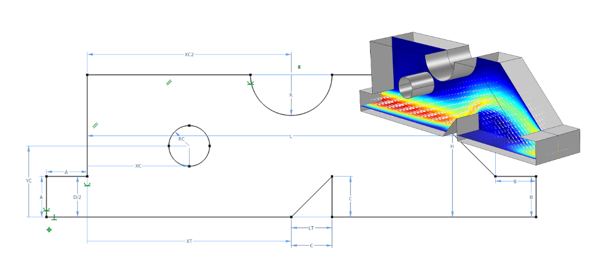
BANGALORE, INDIA (November 14, 2019) — COMSOL, the leading provider of software solutions for multiphysics modeling, simulation, and application design and deployment, announces the latest version of its COMSOL Multiphysics® software. In version 5.5, the Design Module provides an entirely new sketching tool for easier creation and more versatile parametric control of geometry models. New and updated solvers speed up a wide range of simulations. Two new add-on products, the Porous Media Flow Module and the Metal Processing Module, further expand the product suite's multiphysics modeling power.
Parametric optimization of fluid flow in a microvalve using the new sketching tool with dimensions and constraints capabilities available in the Design Module.
Powerful Parametric Sketching with Dimensions
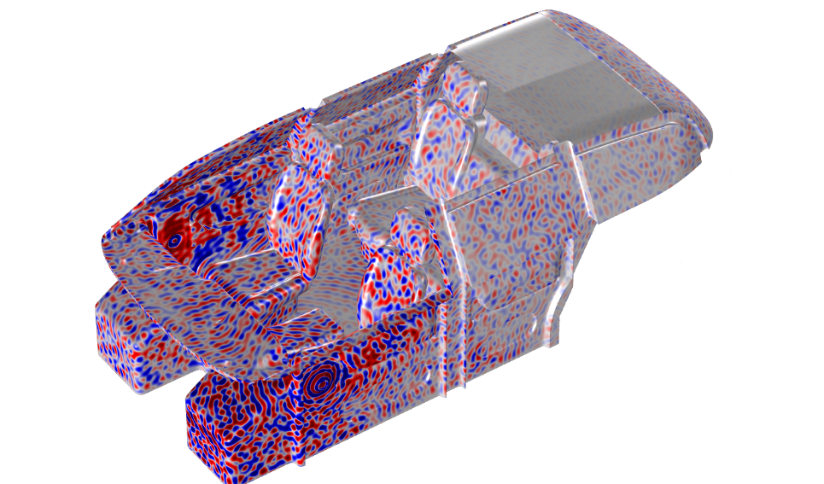
The Design Module provides a new sketching tool that makes it easy to assign dimensions and constraints to planar drawings for 2D models and 3D work planes. "We have carefully integrated the new dimensions and constraints tool in the Model Builder so that it becomes a natural part of the COMSOL Multiphysics workflow," said Daniel Bertilsson, technology manager for mathematics and computer science at COMSOL. "The new tools for dimensions and constraints can be used together with model parameters in COMSOL Multiphysics to drive the simulation, whether for a single run, parametric sweep, or parametric optimization."
Sound pressure field in a car interior solved with the finite element method at 7 kHz using a specialized solver for wave propagation analysis.

New Solver Technology for Acoustics Simulations
Ultrasound technology is becoming increasingly important in a wide range of applications spanning from process engineering and nondestructive testing to consumer electronics. New functionality based on the time-explicit discontinuous Galerkin method enables efficient multicore computations of ultrasound propagation in solids and fluids, including realistic materials featuring damping and anisotropy. The method also has low-frequency applications, such as in seismology. The included multiphysics capabilities can seamlessly combine linear elastic wave propagation in a solid and its transition to a fluid as an acoustic pressure wave, and back again. The new elastic wave functionality is available for users of the Structural Mechanics Module, MEMS Module, and Acoustics Module. The fluid-structure acoustics coupling is available in the Acoustics Module.
For frequency-domain simulations, a specialized solver for wave propagation analysis makes it possible to handle higher frequencies (shorter wavelengths) using the finite element method. The new solver can be used to analyze enclosed structures such as that of a car cabin interior as well as other acoustics simulations.

Introducing the Metal Processing Module
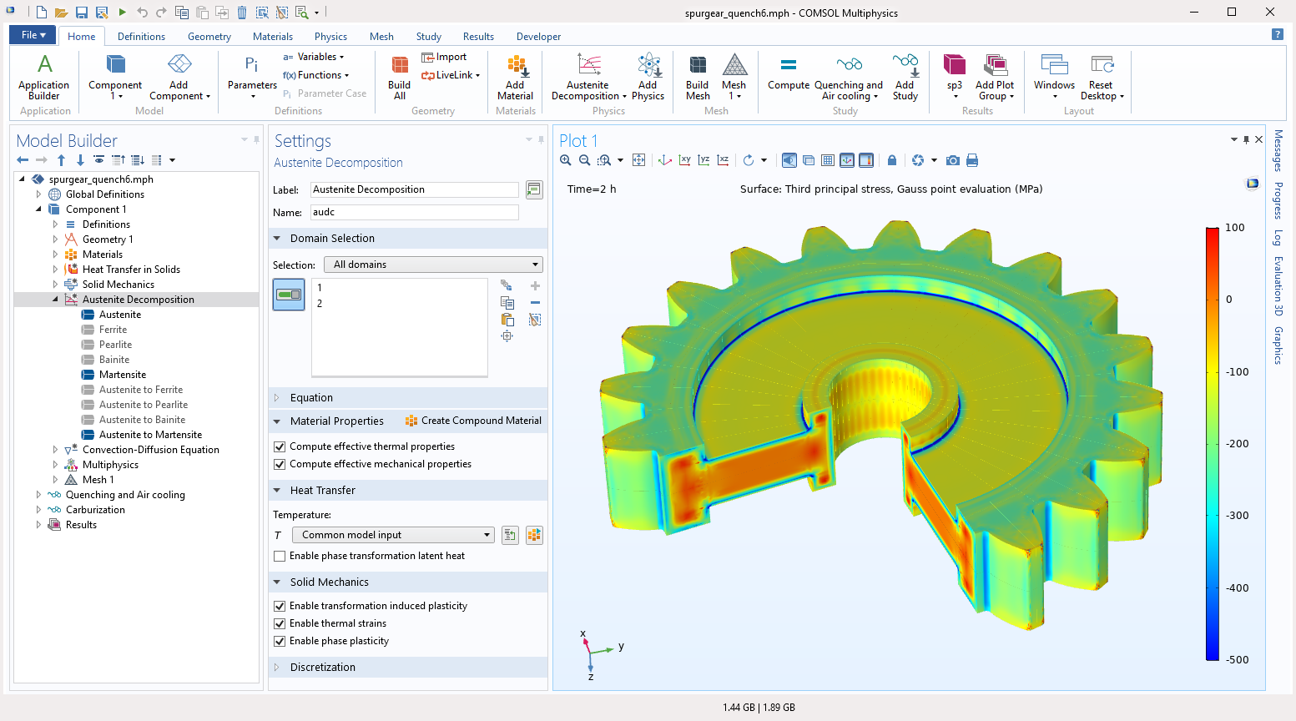
The new Metal Processing Module makes metal phase transformation analysis accessible within the COMSOL Multiphysics environment for applications within welding, heat treatment, and metal additive manufacturing. "The Metal Processing Module makes it possible to predict deformations, stresses, and strains resulting from wanted or unwanted heat-driven phase changes in metals," said Mats Danielsson, technical product manager at COMSOL. "The module can be combined with any of the other COMSOL products for virtually any kind of multiphysics analysis that includes metal phase change. We envision users combining this with, for example, the Heat Transfer Module for the influence of heat radiation, the AC/DC Module for induction hardening, and the Nonlinear Structural Materials Module for highly predictive analysis of material behavior."
Residual stresses in a spur gear after quenching, calculated using the Metal Processing Module.

Introducing the Porous Media Flow Module
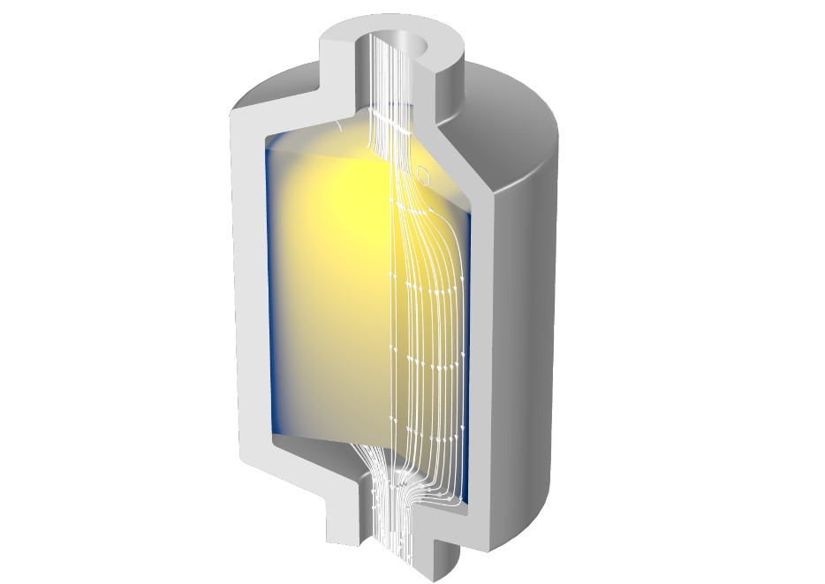
The Porous Media Flow Module gives users within, for example, food, pharmaceutical, and biomedical industries a wide range of transport analysis capabilities for porous media. The new add-on product includes functionality for single- and multiphase flow in porous media, drying, and transport in fractures. The flow models cover linear and nonlinear flow in saturated and variably saturated media with special options for slow and fast porous media flows. The multiphysics simulation capabilities are extensive, with functionality that includes options for calculating effective thermal properties for multicomponent systems; poroelasticity; and transport of chemical species in solid, liquid, and gas phases.
Simulation of a packed bed latent heat storage tank, using the Porous Media Flow Module.

Simplified Shape and Topology Optimization with the Optimization Module
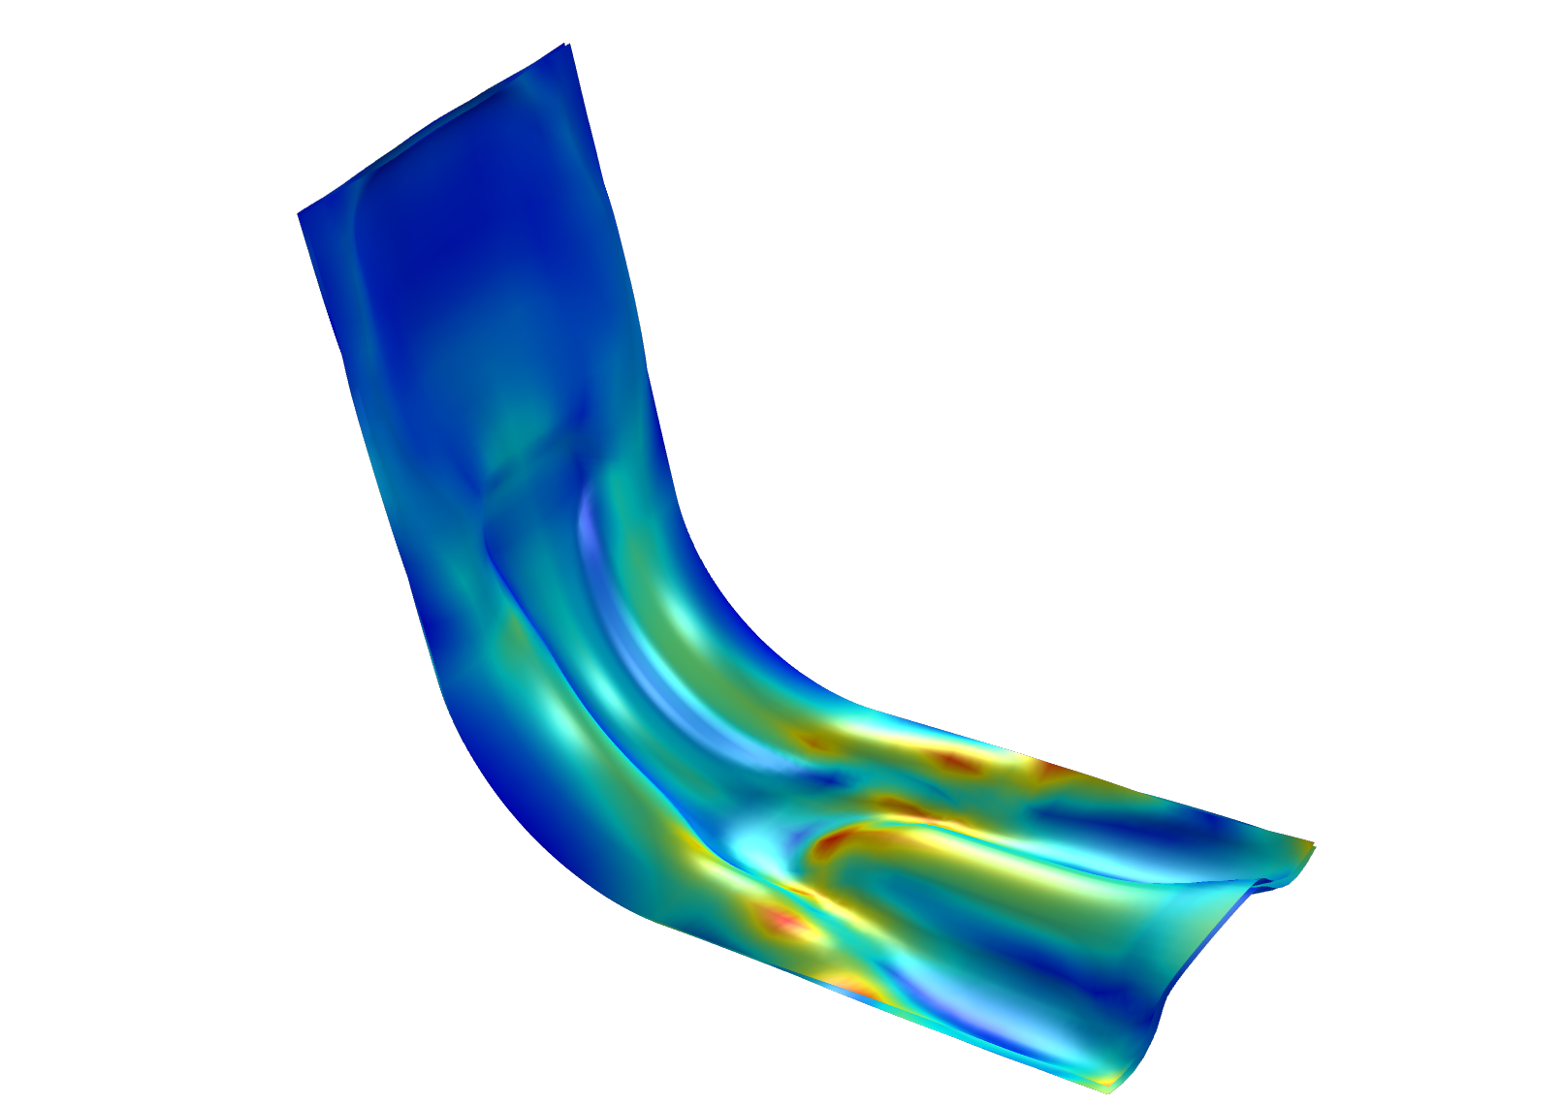
Users working with mechanical, acoustics, electromagnetics, heat, fluid, and chemical analysis have been able to perform shape and topology optimization in COMSOL Multiphysics for many years. The Optimization Module now offers simplified setup of shape optimization with new built-in features such as moving boundaries parameterized by polynomials and built-in support for shell thickness optimization. A new smoothing operation for topology optimization ensures higher-quality geometry outputs that can be used for additional analysis and additive manufacturing. COMSOL Multiphysics now has general support for import and export of the additive manufacturing formats PLY and 3MF, in addition to the STL format that is already available.
Shape optimization of a sheet metal bracket using the Optimization Module. The structure is subjected to a bending load resulting in ridges in the optimal design.

Nonlinear Shell Analysis, Pipe Mechanics, and Random Vibration Analysis
A wide range of nonlinear analysis options are now available for shells and composite shells, including plasticity, creep, viscoplasticity, viscoelasticity, hyperelasticity, and mechanical contact. The mechanical contact modeling functionality has been extended to support any combination of solids and shells, including solid-shell, solid-composite shell, and membrane-shell. Depending on the type of analysis, these improvements will be available to users of the Structural Mechanics Module, Nonlinear Structural Materials Module, and Composite Materials Module.

For users of the Structural Mechanics Module, a new user interface for pipe mechanics provides functionality to perform stress analysis of pipe systems. The new functionality can handle a variety of pipe cross sections and can include effects from external loads, internal pressure, axial drag forces, and temperature gradients through the pipe wall.

Users of the Structural Mechanics Module can now perform random vibration analysis to study the response to loads that are represented by their power spectral density (PSD).
This allows users to include loads that are random in nature, such as turbulent wind gusts or road-induced vibrations on a vehicle. The loads can be fully correlated, uncorrelated, or have a specific user-given correlation.

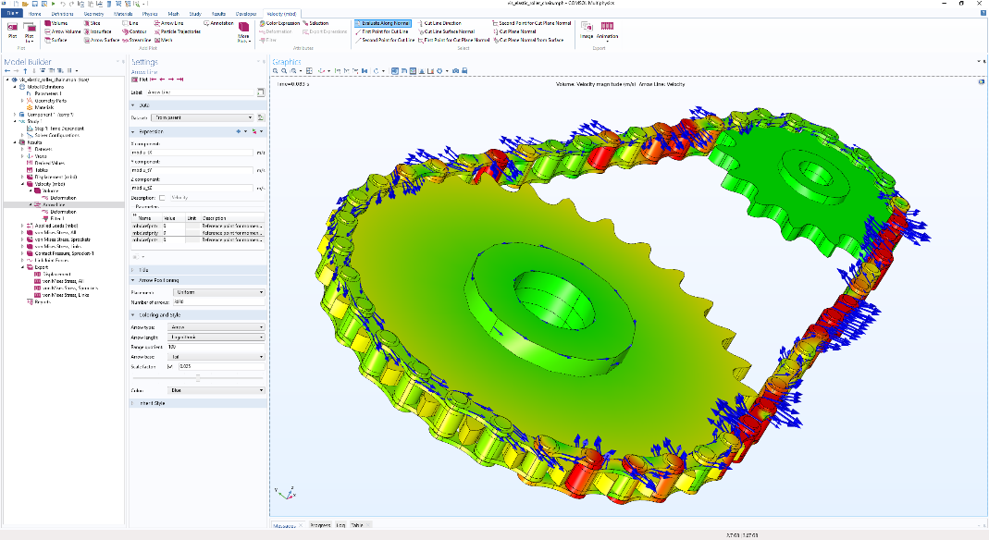
The Multibody Dynamics Module provides new functionality for analyzing rigid and elastic chain drives with automatic generation of the large number of links and joints needed for modeling chain drives.
Elastic chain drive analysis in the Multibody Dynamics Module. Colors and arrows show the velocity and velocity direction, respectively, in the chain and sprockets.

Compressible Euler Flow and Nonisothermal Large Eddy Simulations
Users of the CFD Module will get new interfaces for compressible Euler flow and nonisothermal large eddy simulations (LES). In addition, the flow interfaces for rotating machinery now support the level set and phase field methods as well as Euler–Euler and bubbly flow. The Heat Transfer Module comes with a new interface for lumped thermal systems, an equivalent circuit modeling approach for heat transfer simulations. Radiation in semitransparent (participating) media now supports multiple spectral bands, and a new open boundary formulation for convective flow reduces solution time by 30%.
Multiscale Wave and Ray Optics, Piezoelectric Shells, and PCB Ports
The Ray Optics Module can now be combined with the RF Module or Wave Optics Module for simultaneous full-wave and ray tracing simulations. This enables multiscale modeling, such as analyzing a waveguide beaming into a large room, where using a full-wave simulation would be computationally prohibitive. Combining the AC/DC Module and the Composite Materials Module, users can now analyze layered materials with both dielectric and piezoelectric layers in thin structures. In the RF Module, a set of new ports for vias and transmission lines makes setup much quicker and gives more control to the user for modeling of printed circuit boards.

Efficient Distribution of Standalone Applications
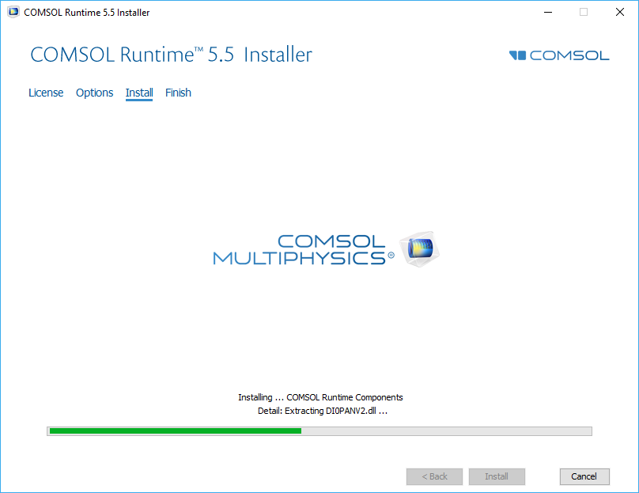
COMSOL Compiler™ enables you to create standalone applications based on COMSOL Multiphysics models with specialized user interfaces that have been built with the Application Builder. Compiled applications require only COMSOL Runtime™ — no COMSOL Multiphysics or COMSOL Server™ license is required. "Since the release of COMSOL Compiler last fall, we have seen great response from our Application Builder users with this new possibility of distributing their applications in standalone form," said Daniel Ericsson, application product manager at COMSOL. The latest version of COMSOL Compiler has a new compile option for generating minimum-sized files for easier distribution. When the user launches an application for the first time, where the new compile option has been used, COMSOL Runtime is downloaded and installed, if needed, from COMSOL's website. Only one instance of COMSOL Runtime is needed for applications using the same COMSOL version. COMSOL Runtime has a size of about 350 MB and an application file can be as small as a few MB.
The COMSOL Runtime™ installer for standalone applications created with the Application Builder and compiled with COMSOL Compiler™.
Highlights in Version 5.5
- New sketching tool with dimensions and constraints
- Fast linear elastic wave simulations
- New Metal Processing Module for welding, heat treatment, and metal additive manufacturing
- New Porous Media Flow Module for food, pharmaceutical, and biomedical industries
- Improved tools for shape and topology optimization for mechanical, acoustics, electromagnetics, heat, fluid, and chemical analysis
- Import and export of the 3D printing and additive manufacturing formats PLY and 3MF
- Editing tools for repair of STL, PLY, and 3MF files
- Structural analysis of nonlinear shells, pipe mechanics, random vibration, and chain drives
- Compressible Euler flow and nonisothermal large eddy simulation (LES)
- Rotating machinery with level set, phase field, Euler–Euler, and bubbly flow
- Lumped thermal system equivalent circuits
- Multiple spectral bands for radiation in participating media
- More efficient open boundary condition for convective heat transfer
- Use of thermodynamic database properties in any simulation type
- Combined full wave and ray optics simulations
- Piezoelectric and dielectric shells
- New PCB ports for vias and transmission lines
- Link images to Microsoft® PowerPoint® presentations
- Create your own add-ins for customizing the Model Builder workflow
- Minimal file size standalone applications with COMSOL Compiler™

Availability
COMSOL Multiphysics, COMSOL Server, and COMSOL Compiler software products are supported on the following operating systems: Windows®, Linux®, and macOS. The Application Builder tool is supported in the Windows® operating system.

To browse version 5.5 release highlights, visit: www.comsol.co.in/release/5.5

To download the latest version, visit: www.comsol.co.in/product-download

About COMSOL
COMSOL is a global provider of simulation software for product design and research to technical enterprises, research labs, and universities. Its COMSOL Multiphysics® product is an integrated software environment for creating physics-based models and simulation apps. A particular strength is its ability to account for coupled or multiphysics phenomena. Add-on products expand the simulation platform for electromagnetics, structural, acoustics, fluid flow, heat transfer, and chemical applications. Interfacing tools enable the integration of COMSOL Multiphysics® simulations with all major technical computing and CAD tools on the CAE market. Simulation experts rely on COMSOL Compiler™ and COMSOL Server™ to deploy applications to their design teams, manufacturing departments, test laboratories, and customers throughout the world. Founded in 1986, COMSOL has 19 offices worldwide and extends its reach with a network of distributors.
COMSOL, COMSOL Multiphysics, COMSOL Compiler, COMSOL Runtime, and COMSOL Server are either registered trademarks or trademarks of COMSOL AB. For other trademark ownership, see www.comsol.co.in/trademarks.

