COMSOL Multiphysics Pvt. Ltd.  Esquire Center, C - Block, 3rd Floor,  No. 9, M.G. Road, Bangalore 560001, India  Tel:+91-80-2559-7799  Web: www.comsol.co.in  Blog: www.comsol.co.in/blogs/ | Media Contact:  Ashwin S. Mecheri,  ashwin@comsol.com  COMSOL® Client for Android:  https://play.google.com/

Simulation On-The-Go with COMSOL Client for Android™
COMSOL Client for Android™ allows engineers, scientists, and students to run simulation applications from an Android™ device.

BANGALORE, INDIA (April 25, 2019) — COMSOL is excited to announce COMSOL Client for Android™ is now available. Researchers, engineers, and students are now able to perform simulation tasks from their Android™ devices, such as phones, tablets, and Chromebooks simply by connecting to the COMSOL Server™ software which runs the computations remotely.

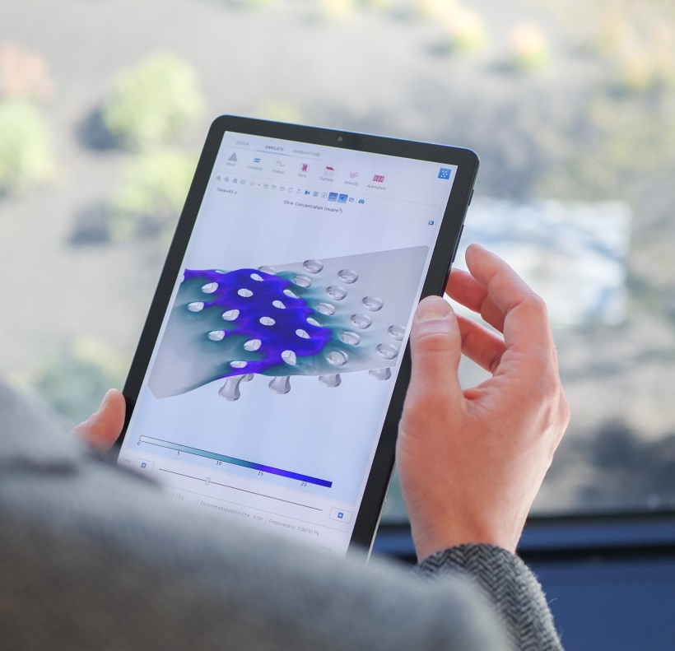
COMSOL Client for Android™ expands on the capabilities of the Application Builder and COMSOL Server by enabling you to take your simulation applications on the road, without being limited by your device hardware. Providing field technicians or sales representatives with the power of COMSOL Multiphysics® directly on their Android devices allows them to bring the R&D work on site or to the sales pitch.

“COMSOL Server allows users to run simulations through web browsers or desktop-installed clients,” explains Daniel Ericsson, Applications Product Manager, COMSOL. “COMSOL Client for Android expands on those capabilities by introducing a more seamless user experience on Android devices.”

“Using COMSOL Multiphysics and its Application Builder I can create models and build apps based on them. This allows other departments to test different configurations for their particular requirements and pick the best design”, comments Sam Parler, Research Director at Cornell Dubilier.
COMSOL Client for Android™ enables you to take your simulation applications on the road, without being limited by your device hardware.

The Application Builder and COMSOL Server were developed to make multiphysics modeling more accessible to a wider audience. The Application Builder allows simulation specialists to create custom-made applications based on their multiphysics models. With COMSOL Server, organizations have been able to deploy industry-specific analysis tools in a streamlined and quick to implement format that can be scaled for global benefit. COMSOL Client for Android has made the convenience of running simulation applications as easy as ordering a rideshare.

“Expanding the reach of multiphysics modeling is at the core of our mission,” adds Daniel Ericsson. “COMSOL Client for Android will allow everyone from design engineers to field technicians be more efficient with the ability to run COMSOL Multiphysics simulations from the palm of their hands.”

Just like COMSOL Client for Windows®, the simulations are run on remote servers, so you are not limited by your device hardware. Administrators continue to have full control over who can access and run the apps by using COMSOL Server. Android™ users will have the latest version of a simulation application each time they open the app.

Learn more about COMSOL Client for Android: https://play.google.com/store/apps/details?id=com.comsol.androidclient

About COMSOL
COMSOL is a global provider of simulation software for product design and research to technical enterprises, research labs, and universities. Its COMSOL Multiphysics® product is an integrated software environment for creating physics-based models and simulation applications. A particular strength is its ability to account for coupled or multiphysics phenomena. Add-on products expand the simulation platform for electromagnetics, structural, acoustics, fluid flow, heat transfer, and chemical applications. Interfacing tools enable the integration of COMSOL Multiphysics® simulations with all major technical computing and CAD tools on the CAE market. Simulation experts rely on COMSOL Compiler™ and COMSOL Server™ to deploy applications to their design teams, manufacturing departments, test laboratories, and customers throughout the world. Founded in 1986, COMSOL has 19 offices worldwide and extends its reach with a network of distributors.
~
COMSOL, COMSOL Multiphysics, LiveLink, COMSOL Compiler, COMSOL Runtime, and COMSOL Server are either registered trademarks or trademarks of COMSOL AB. For other trademark ownership, see www.comsol.co.in/trademarks.

