COMSOL Multiphysics Pvt. Ltd.  Esquire Center, C - Block, 3rd Floor,  No. 9, M.G. Road, Bangalore 560001, India  Tel:+91-80-2559-7799  Web: www.comsol.co.in  E-mail: info@comsol.co.in | Media Contact:  Ashwin S. Mecheri,  ashwin@comsol.com  COMSOL® Learning Center (CLC):  www.comsol.co.in/learning-center

COMSOL Learning Center is Now Available to All Engineers
The Learning Center features a series of video tutorials in a self-guided learning environment that gives users a comprehensive introduction to working with the COMSOL Multiphysics® software.

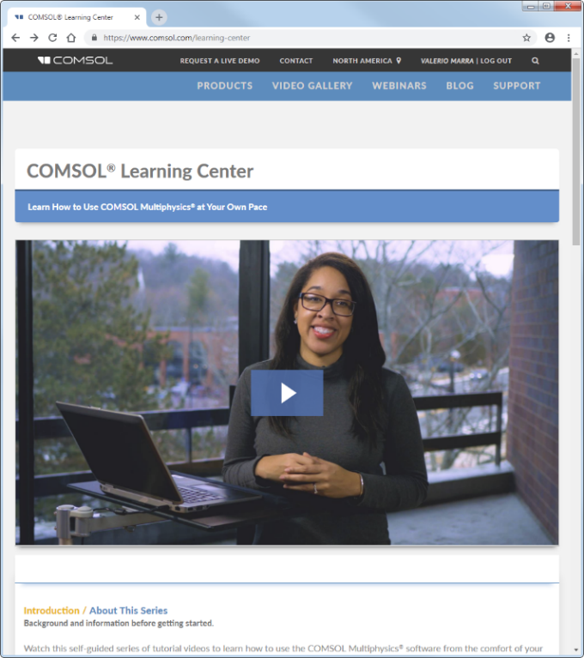
BANGALORE, INDIA (December 14, 2018) — COMSOL is excited to announce the COMSOL® Learning Center is now available to all engineers.

“This collection of instructional videos serves as a one-stop shop to learn how to use the software,” comments Amelia Halliday, Project Manager, COMSOL. “The COMSOL® Learning Center will provide COMSOL users with a breadth and depth of learning that fully equips and enables them to take on any simulation situation.”

There are 30+ self-service, self-paced tutorials consisting of videos and additional resources such as exercise model files and blog posts for an interactive and hands-on learning experience. The contents are based on the fundamental steps in the modeling and simulation workflow, including building a geometry, adding physics, solving, and postprocessing results.

“The COMSOL® Learning Center is available to any engineer that is interested in adopting multiphysics modeling,” adds Andrew Griesmer, Project Manager, COMSOL. “We want to make sure our customers get the most out of COMSOL Multiphysics®, and this online resource delivers on that by providing a guided learning experience to all types of users, at their own pace, anytime and anywhere.”

The COMSOL Learning Center is available at www.comsol.co.in/learning-center and only requires an internet connection.

About COMSOL
COMSOL is a global provider of simulation software for product design and research to technical enterprises, research labs, and universities. Its COMSOL Multiphysics® product is an integrated software environment for creating physics-based models and simulation applications. A particular strength is its ability to account for coupled or multiphysics phenomena. Add-on products expand the simulation platform for electromagnetics, structural, acoustics, fluid flow, heat transfer, and chemical applications. Interfacing tools enable the integration of COMSOL Multiphysics® simulations with all major technical computing and CAD tools on the CAE market. Simulation experts rely on COMSOL Compiler™ and COMSOL Server™ to deploy applications to their design teams, manufacturing departments, test laboratories, and customers throughout the world. Founded in 1986, COMSOL has 19 offices worldwide and extends its reach with a network of distributors.
~
COMSOL, COMSOL Multiphysics, LiveLink, COMSOL Compiler, COMSOL Runtime, and COMSOL Server are either registered trademarks or trademarks of COMSOL AB. For other trademark ownership, see www.comsol.co.in/trademarks.

