COMSOL Multiphysics Pvt. Ltd.  Esquire Center, C - Block, 3rd Floor,  No. 9, M.G. Road, Bangalore 560001, India  Tel:+91-80-2559-7799  Web: www.comsol.co.in  E-mail: info@comsol.co.in | Media Contact:  Ashwin S. Mecheri,  ashwin@comsol.com  Blog post: Ray Optics Simulation of Sagnac Interferometers and Ring Laser Gyros

Ray Optics Simulation of Rotating Devices
for Aerospace and Defense Applications

COMSOL Multiphysics® and its add-on product, the Ray Optics Module, allow for the simulation of optical phenomena in laser and fiber ring gyroscopes.

BANGALORE, INDIA (May 30, 2018) — Engineers developing technologies such as laser and fiber ring gyroscopes for civilian and military applications can now test new ideas and configurations in the virtual world using numerical simulation. The Ray Optics Module, an add-on product to the COMSOL Multiphysics® software, supports the ability to accurately trace rays through a moving geometry.
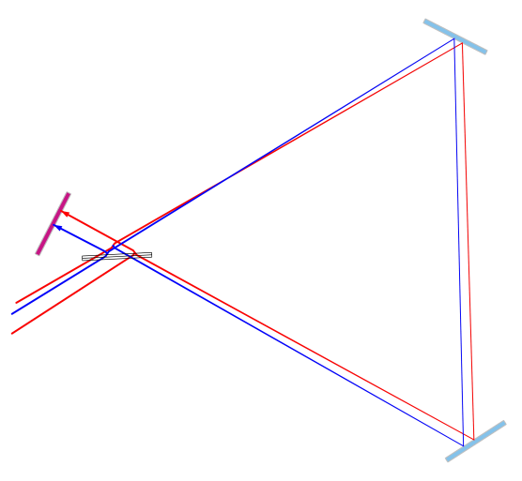
To showcase this capability, COMSOL is excited to announce the addition of a Sagnac Interferometer example model, complete with documentation and solution, to the Application Galleries. The new example provides simulation specialists with a working application of the Sagnac effect, the fundamental operating principle of ring laser gyroscopes, and will help those working with attitude detection to get a better understanding of the sensitivity and accuracy of such complex inertial navigation systems.

"We are very excited to share the Sagnac Interferometer model with the simulation community," says Christopher Boucher, Technical Product Manager, COMSOL, Inc. "Just specify the angular velocity, and then you can accurately trace rays through the interferometer as it rotates, even though the two phenomena happen over vastly different time scales. This is a real game changer for those working in the aerospace and defense industries. To our knowledge no other commercial software solution is able to execute this.” The movement in the example model is simple rotation, but the same capability could be applied to combinations of translation and rotation. Multiphysics models can also be built coupling ray tracing with structural deformation, including thermal stress.
Visualization of counterpropagating light rays in a counterclockwise rotating Sagnac interferometer.

The Application Galleries features hundreds of example models and apps to help simulation specialists get started using COMSOL Multiphysics®.

About COMSOL
COMSOL is a global provider of simulation software for product design and research to technical enterprises, research labs, and universities. Its COMSOL Multiphysics® product is an integrated software environment for creating physics-based models and simulation apps. A particular strength is its ability to account for coupled or multiphysics phenomena. Add-on products expand the simulation platform for electromagnetics, structural, acoustics, fluid flow, heat transfer, and chemical applications. Interfacing tools enable the integration of COMSOL Multiphysics® simulations with all major technical computing and CAD tools on the CAE market. Simulation experts rely on the COMSOL Server™ product to deploy apps to their design teams, manufacturing departments, test laboratories, and customers throughout the world. Founded in 1986, COMSOL employs more than 450 people in 19 offices worldwide and extends its reach with a network of distributors.
~
COMSOL, COMSOL Multiphysics, LiveLink, and COMSOL Server are either registered trademarks or trademarks of COMSOL AB. For other trademark ownership, see www.comsol.co.in/trademarks.

